**Practical No 3**

1. **Create a simple web page with various server controls to demonstrate setting setting and use of their properties.(Example : AutoPostBack)**

**C# code:**

<%@ Page Language="C#" AutoEventWireup="true" CodeBehind="WebForm1.aspx.cs" Inherits="autopostback.WebForm1" %>

<!DOCTYPE html>

<html xmlns="http://www.w3.org/1999/xhtml">

<head runat="server">

<title></title>

<style type="text/css">

.auto-style1 {

position: absolute;

top: 305px;

left: 581px;

z-index: 1;

}

.auto-style2 {

position: absolute;

top: 201px;

left: 711px;

z-index: 1;

width: 101px;

height: 23px;

}

.auto-style3 {

height: 569px;

}

.auto-style4 {

position: absolute;

top: 149px;

left: 710px;

z-index: 1;

}

.auto-style5 {

position: absolute;

top: 261px;

left: 579px;

z-index: 1;

}

.auto-style6 {

position: absolute;

top: 101px;

left: 586px;

z-index: 1;

}

.auto-style7 {

position: absolute;

top: 100px;

left: 717px;

z-index: 1;

}

.auto-style8 {

position: absolute;

top: 201px;

left: 568px;

z-index: 1;

}

.auto-style9 {

position: absolute;

top: 150px;

left: 585px;

z-index: 1;

}

</style>

</head>

<body>

<form id="form1" runat="server">

<div class="auto-style3">

<center><h2>ASP.NET Server Control</h2></center>

<asp:Label ID="lblinfo" runat="server" Text="Select a City : " CssClass="auto-style6"></asp:Label>

<asp:DropDownList ID="ddlColors" runat="server" AutoPostBack="true" OnSelectedIndexChanged="ddlColors_SelectedIndexChanged" CssClass="auto-style7">

<asp:ListItem>vengurla</asp:ListItem>

<asp:ListItem>kudal</asp:ListItem>

<asp:ListItem>sawantwadi</asp:ListItem>

<asp:ListItem>dodamarg</asp:ListItem>

<asp:ListItem>kankavali</asp:ListItem>

<asp:ListItem>malvan</asp:ListItem>

<asp:ListItem>devgad</asp:ListItem>

<asp:ListItem>vaibhavwadi</asp:ListItem>

<asp:ListItem></asp:ListItem>

</asp:DropDownList>

<asp:Label ID="lblCity" runat="server" ForeColor="Black" CssClass="auto-style1"></asp:Label>

<br />

<asp:Label ID="lblTextBox" runat="server" Text="You entered : " CssClass="auto-style5"></asp:Label>

<br />

<asp:CheckBox ID="chkEnableButton" runat="server" Text="Enable Button" AutoPostBack="true" OnCheckedChanged="chkEnableButton_CheckedChanged" CssClass="auto-style8"/>

<br />

<asp:Button ID="btnSubmit" runat="server" Text="Submit" Enabled="false" OnClick="btnSubmit_Click" CssClass="auto-style2" />

<br />

<asp:TextBox ID="txtInput" runat="server" AutoPostBack="true" OnTextChanged="txtInput_TextChanged" CssClass="auto-style4"></asp:TextBox>

<asp:Label ID="Label2" runat="server" CssClass="auto-style9" Text="State : "></asp:Label>

</div>

</form>

</body>

</html>

**aspx code:**

using System;

using System.Collections.Generic;

using System.Linq;

using System.Web;

using System.Web.UI;

using System.Web.UI.WebControls;

namespace autopostback

{

public partial class WebForm1 : System.Web.UI.Page

{

protected void Page_Load(object sender, EventArgs e)

{

}

protected void ddlColors_SelectedIndexChanged(object sender, EventArgs e)

{

lblCity.Text = "You Selected : " + ddlColors.SelectedItem.Text;

}

protected void chkEnableButton_CheckedChanged(object sender, EventArgs e)

{

btnSubmit.Enabled = chkEnableButton.Checked;

}

protected void btnSubmit_Click(object sender, EventArgs e)

{

lblCity.Text = "Button Clicked!";

}

protected void txtInput_TextChanged(object sender, EventArgs e)

{

lblTextBox.Text = "You entered : " + txtInput.Text;

}

}

}

**output:**

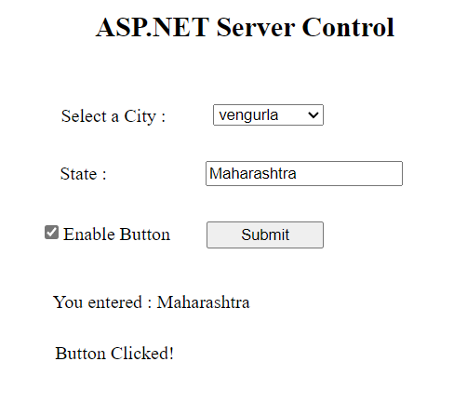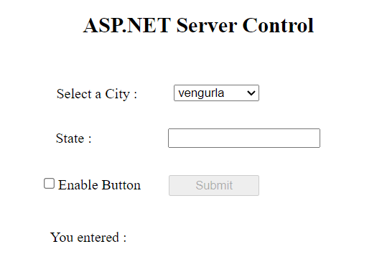

1. **Create a registration form to demonstrate use of various validation controls.**

**C# code:**

using System;

using System.Collections.Generic;

using System.Linq;

using System.Web;

using System.Web.UI;

using System.Web.UI.WebControls;

namespace pract3b

{

public partial class WebForm1 : System.Web.UI.Page

{

protected void Page_Load(object sender, EventArgs e)

{

}

protected void TextBox1_TextChanged(object sender, EventArgs e)

{

}

protected void Button1_Click(object sender, EventArgs e)

{

Response.Write("Submitted");

}

protected void TextBox6_TextChanged(object sender, EventArgs e)

{

}

protected void CustomValidator1_ServerValidate(object source, ServerValidateEventArgs args)

{

string cnty = TextBox6.Text;

if(cnty == "India" || cnty=="INDIA" || cnty == "india")

{

args.IsValid = true;

}

else

{

args.IsValid = false;

}

}

}

}

**aspx code:**

<%@ Page Language="C#" AutoEventWireup="true" CodeBehind="WebForm1.aspx.cs" Inherits="pract3b.WebForm1" %>

<!DOCTYPE html>

<html xmlns="http://www.w3.org/1999/xhtml">

<head runat="server">

<title></title>

<style type="text/css">

.auto-style1 {

position: absolute;

top: 168px;

left: 813px;

z-index: 1;

}

.auto-style2 {

position: absolute;

top: 70px;

left: 677px;

z-index: 1;

}

.auto-style3 {

position: absolute;

top: 164px;

left: 626px;

z-index: 1;

height: 23px;

}

.auto-style4 {

position: absolute;

top: 236px;

left: 625px;

z-index: 1;

}

.auto-style5 {

position: absolute;

top: 292px;

left: 622px;

z-index: 1;

}

.auto-style6 {

position: absolute;

top: 352px;

left: 627px;

z-index: 1;

}

.auto-style7 {

position: absolute;

top: 413px;

left: 626px;

z-index: 1;

}

.auto-style8 {

position: absolute;

top: 229px;

left: 812px;

z-index: 1;

}

.auto-style9 {

position: absolute;

top: 288px;

left: 813px;

z-index: 1;

}

.auto-style10 {

position: absolute;

top: 351px;

left: 817px;

z-index: 1;

}

.auto-style11 {

position: absolute;

top: 413px;

left: 814px;

z-index: 1;

}

.auto-style12 {

position: absolute;

top: 544px;

left: 782px;

z-index: 1;

}

.auto-style13 {

position: absolute;

top: 169px;

left: 1003px;

z-index: 1;

}

.auto-style14 {

position: absolute;

top: 288px;

left: 1002px;

z-index: 1;

}

.auto-style15 {

position: absolute;

top: 355px;

left: 1007px;

z-index: 1;

}

.auto-style16 {

position: absolute;

top: 415px;

left: 1017px;

z-index: 1;

}

.auto-style17 {

position: absolute;

top: 231px;

left: 1001px;

z-index: 1;

}

.auto-style18 {

position: absolute;

top: 288px;

left: 1003px;

z-index: 1;

bottom: 367px;

}

.auto-style19 {

position: absolute;

top: 352px;

left: 1008px;

z-index: 1;

}

.auto-style20 {

position: absolute;

top: 413px;

left: 1010px;

z-index: 1;

}

.auto-style21 {

position: absolute;

top: 478px;

left: 625px;

z-index: 1;

}

.auto-style22 {

position: absolute;

top: 478px;

left: 817px;

z-index: 1;

right: 560px;

width: 152px;

height: 17px;

}

.auto-style23 {

position: absolute;

top: 472px;

left: 1021px;

z-index: 1;

}

.auto-style24 {

position: absolute;

top: 473px;

left: 1020px;

z-index: 1;

}

.auto-style25 {

width: 1830px;

height: 44px;

position: absolute;

top: 595px;

left: 717px;

z-index: 1;

}

</style>

</head>

<body>

<form id="form1" runat="server">

<div>

<asp:Label ID="Label1" runat="server" Text="Registration Form" CssClass="auto-style2" Font-Bold="True" Font-Size="XX-Large"></asp:Label>

<asp:TextBox ID="TextBox1" runat="server" CssClass="auto-style1" OnTextChanged="TextBox1_TextChanged"></asp:TextBox>

</div>

<asp:Label ID="Label2" runat="server" CssClass="auto-style3" Text="Name"></asp:Label>

<asp:Label ID="Label3" runat="server" CssClass="auto-style4" Text="Password"></asp:Label>

<p>

<asp:Label ID="Label4" runat="server" CssClass="auto-style5" Text="Confirm Password"></asp:Label>

<asp:Label ID="Label5" runat="server" CssClass="auto-style6" Text="Age"></asp:Label>

</p>

<asp:Label ID="Label6" runat="server" CssClass="auto-style7" Text="Email"></asp:Label>

<p>

<asp:TextBox ID="TextBox2" runat="server" CssClass="auto-style8"></asp:TextBox>

</p>

<asp:TextBox ID="TextBox3" runat="server" CssClass="auto-style9"></asp:TextBox>

<asp:TextBox ID="TextBox4" runat="server" CssClass="auto-style10"></asp:TextBox>

<asp:TextBox ID="TextBox5" runat="server" CssClass="auto-style11"></asp:TextBox>

<asp:Button ID="Button1" runat="server" CssClass="auto-style12" OnClick="Button1_Click" Text="Submit" />

<asp:Label ID="Label7" runat="server" CssClass="auto-style21" Text="Country"></asp:Label>

<asp:TextBox ID="TextBox6" runat="server" CssClass="auto-style22" OnTextChanged="TextBox6_TextChanged"></asp:TextBox>

<asp:RequiredFieldValidator ID="RequiredFieldValidator1" runat="server" ControlToValidate="TextBox1" CssClass="auto-style13" ErrorMessage="*Name Required"></asp:RequiredFieldValidator>

<asp:CompareValidator ID="CompareValidator1" runat="server" ControlToCompare="TextBox2" ControlToValidate="TextBox3" CssClass="auto-style14" ErrorMessage="*Password Dose Not Match"></asp:CompareValidator>

<asp:RangeValidator ID="RangeValidator1" runat="server" ControlToValidate="TextBox4" CssClass="auto-style15" ErrorMessage="*Invalid Age(18-35)" MaximumValue="35" MinimumValue="18"></asp:RangeValidator>

<asp:RequiredFieldValidator ID="RequiredFieldValidator2" runat="server" ControlToValidate="TextBox2" CssClass="auto-style17" ErrorMessage="* Password Required"></asp:RequiredFieldValidator>

<asp:RequiredFieldValidator ID="RequiredFieldValidator3" runat="server" ControlToValidate="TextBox3" CssClass="auto-style18" ErrorMessage="* Confirm Password Required"></asp:RequiredFieldValidator>

<asp:RequiredFieldValidator ID="RequiredFieldValidator4" runat="server" ControlToValidate="TextBox4" CssClass="auto-style19" ErrorMessage="*Age Required"></asp:RequiredFieldValidator>

<asp:RequiredFieldValidator ID="RequiredFieldValidator5" runat="server" ControlToValidate="TextBox5" CssClass="auto-style20" ErrorMessage="*Email Required"></asp:RequiredFieldValidator>

<asp:RegularExpressionValidator ID="RegularExpressionValidator1" runat="server" ControlToValidate="TextBox5" CssClass="auto-style16" ErrorMessage="*Incorrect Email Format" ValidationExpression="\w+([-+.']\w+)*@\w+([-.]\w+)*\.\w+([-.]\w+)*"></asp:RegularExpressionValidator>

<asp:RequiredFieldValidator ID="RequiredFieldValidator6" runat="server" ControlToValidate="TextBox6" CssClass="auto-style23" ErrorMessage="*Country Required"></asp:RequiredFieldValidator>

<asp:CustomValidator ID="CustomValidator1" runat="server" CssClass="auto-style24" ErrorMessage="*Only For Indians" OnServerValidate="CustomValidator1_ServerValidate"></asp:CustomValidator>

<asp:ValidationSummary ID="ValidationSummary1" runat="server" CssClass="auto-style25" />

</form>

</body>

</html>

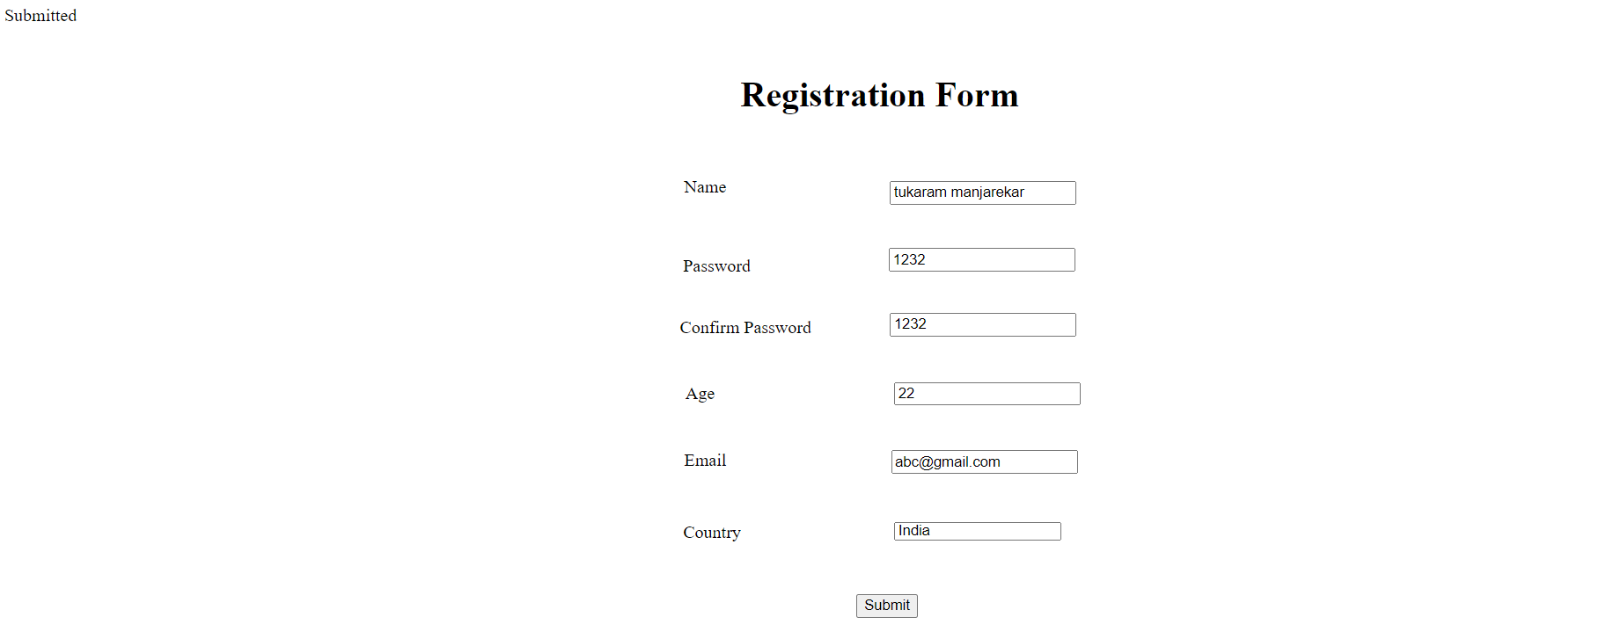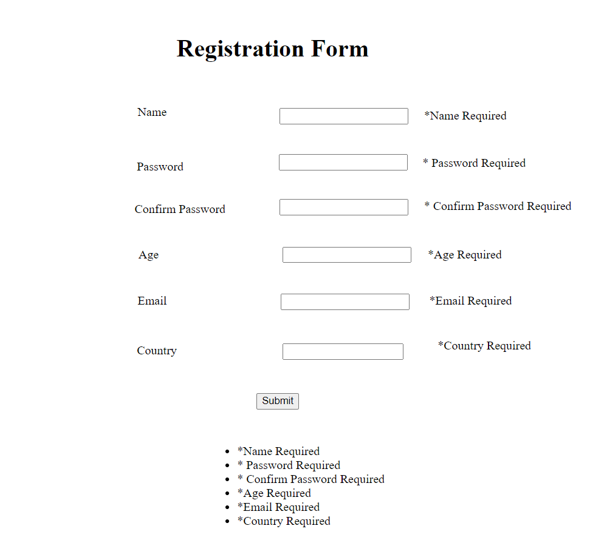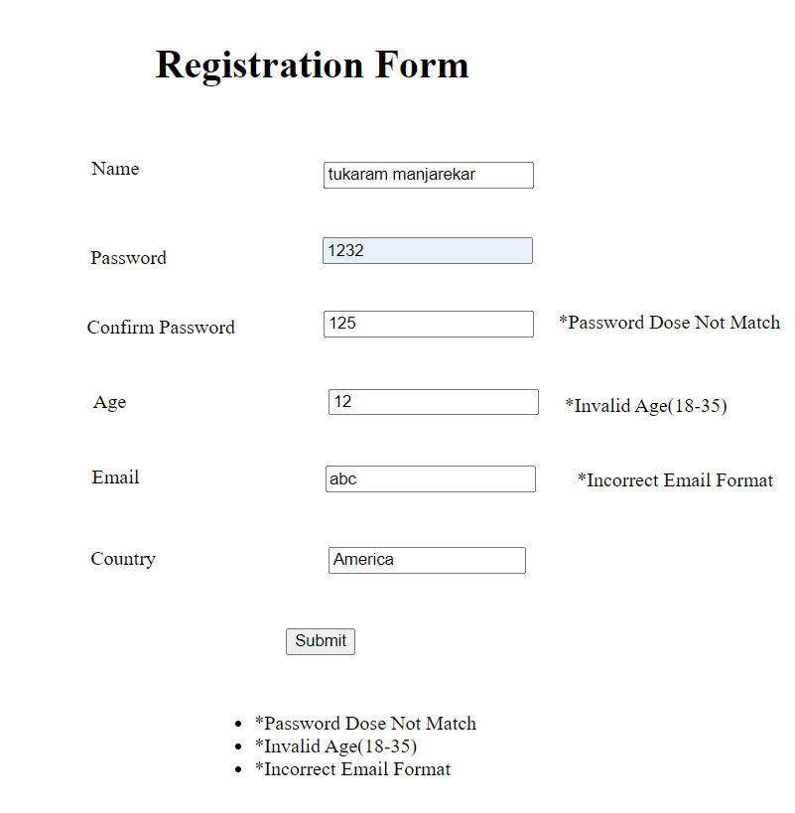**output:**